Jenkins-Assignment-7
Job
Repo –
https://github.com/Shantanumajan6/myapp-project.git
Shell Script-
cd /mnt/server/apache-tomcat-10.1.54/webapps
sudo rm -rf java17-mysql-webapp-1.0*
cd /mnt/slave-machine/workspace/Jenkins-Assignment-7/target
sudo cp -r java17-mysql-webapp-1.0.war /mnt/server/apache-tomcat-10.1.54/webapps
Build Step –

Node 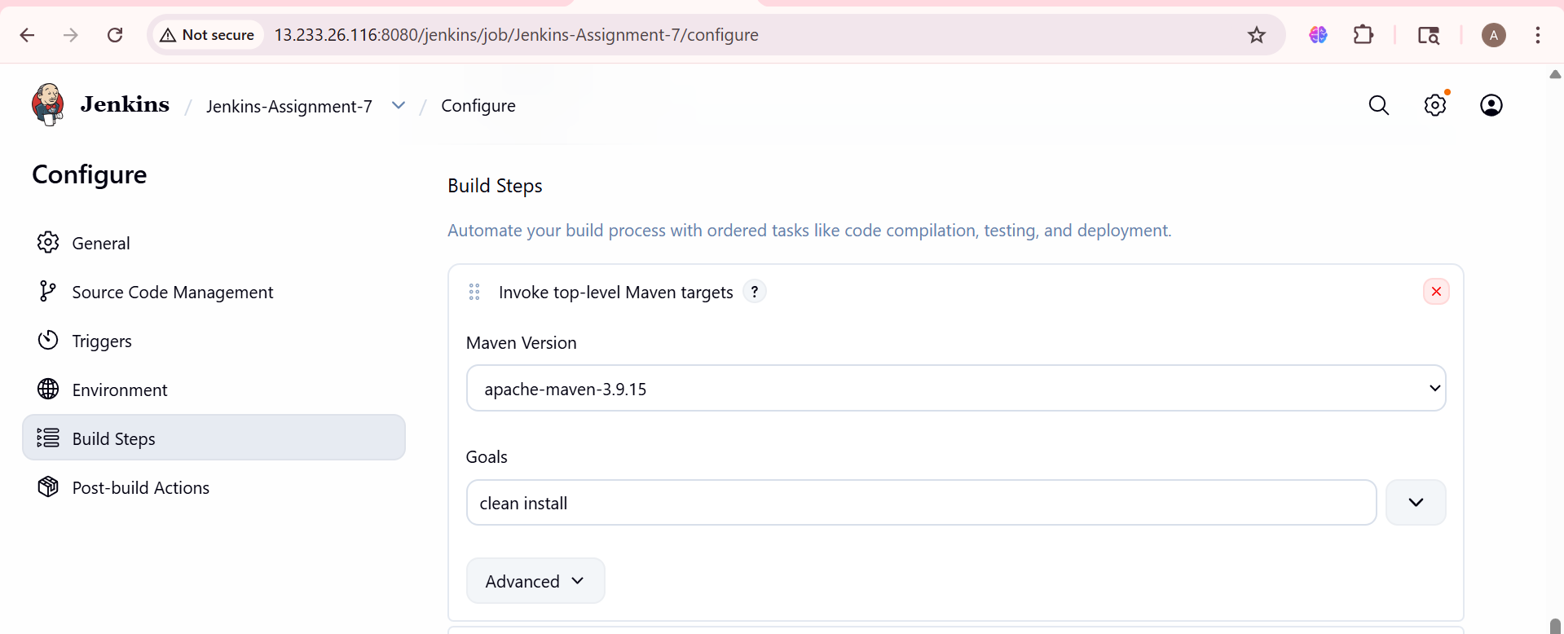

Node Details
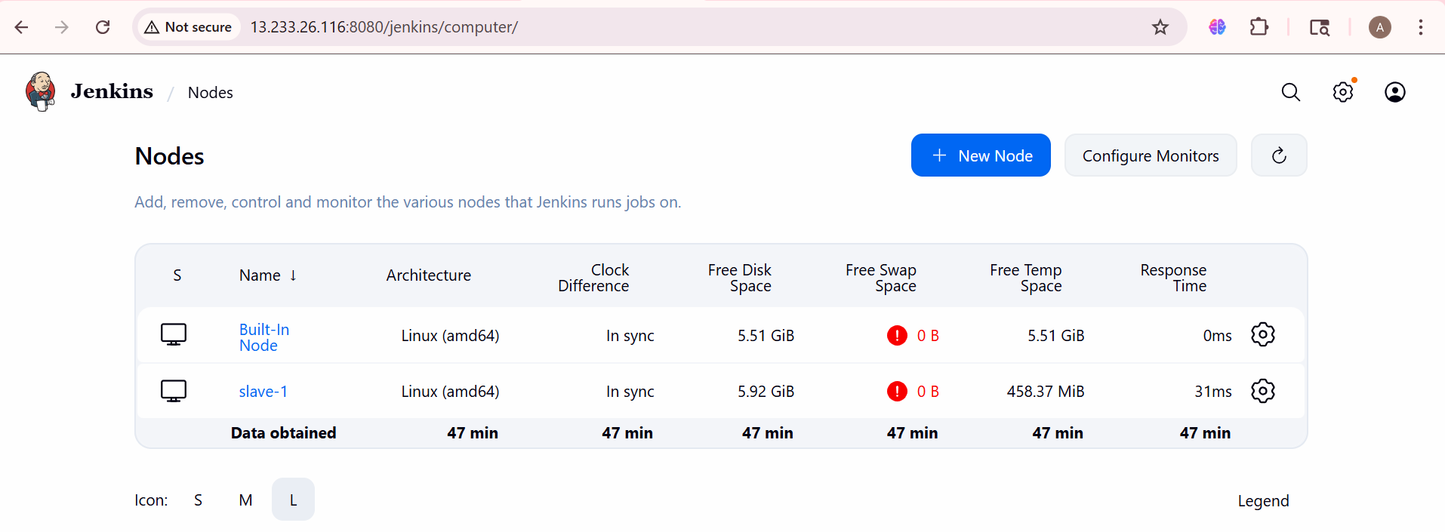

Accessing website from Slave-1
